Phase 8: Data Management & Deployment
Project: Debug Log Analysis and Bug Fixing in Salesforce Apex

1. Objective of Phase 8
The main goal of this phase is to manage the test data required for Apex debugging and deploy all metadata from the Salesforce DX project into the connected Salesforce org.
This ensures that:
- Apex classes, test classes, and optional UI components are ready for execution.
- Test data is correctly set up for generating replay-enabled debug logs.
- The project is fully deployable and reproducible in any org for testing or demonstration purposes.

2. Data Management
Even though this project mainly deals with debugging Apex, proper test data management is essential:
a. Creating Test Data for Apex Execution
- The test class AccountServiceTest.cls generates an Account record with sample data:
  - Name: "Salesforce"
  - Account Number: "SFDC"
  - Ticker Symbol: "CRM"
- Ensures predictable values for debugging.
b. Benefits of Structured Test Data
- Allows breakpoints and checkpoints to capture accurate heap dumps.
- Ensures logs are consistent for Replay Debugger analysis.
- Prevents errors caused by missing or invalid data.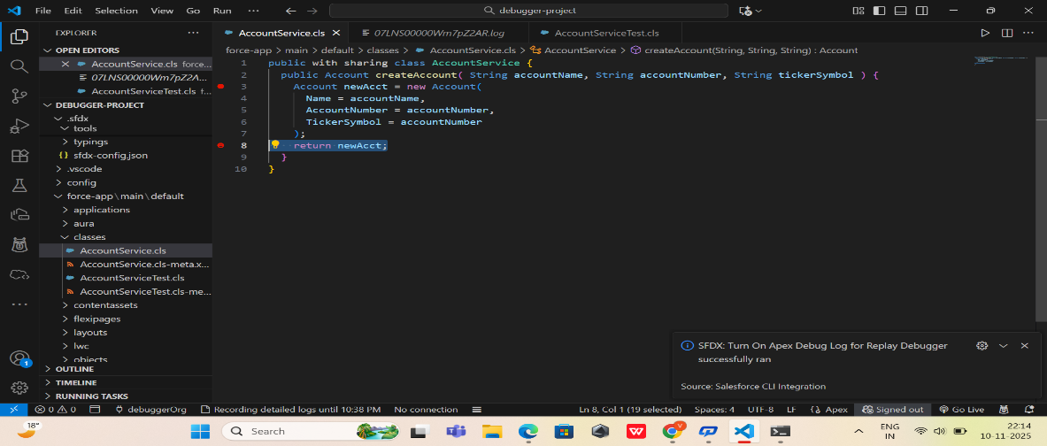

3. Deployment Using Salesforce DX
a. Deploy Metadata to Org
- All Apex classes, test classes, and optional UI components are deployed using:
- SFDX: Deploy Source to Org
- Deployment ensures code is live in the org and ready for testing/debugging.
b. Verification After Deployment
- Run Apex tests using:
- SFDX: Run Apex Tests
- Confirm all tests pass after deploying fixed code.
c. Maintaining Project Structure
- All deployed metadata matches the Salesforce DX project structure:
  - force-app/main/default/classes → Apex classes & test classes
  - force-app/main/default/lwc → Lightning Web Components
  - sfdx-project.json → DX project configuration

4. Role in Debugging Workflow
- Correct data ensures checkpoints and breakpoints work as expected.
- Proper deployment guarantees Apex Replay Debugger can access the right version of code.
- Supports consistent, reproducible debugging for demonstration or future development.
- 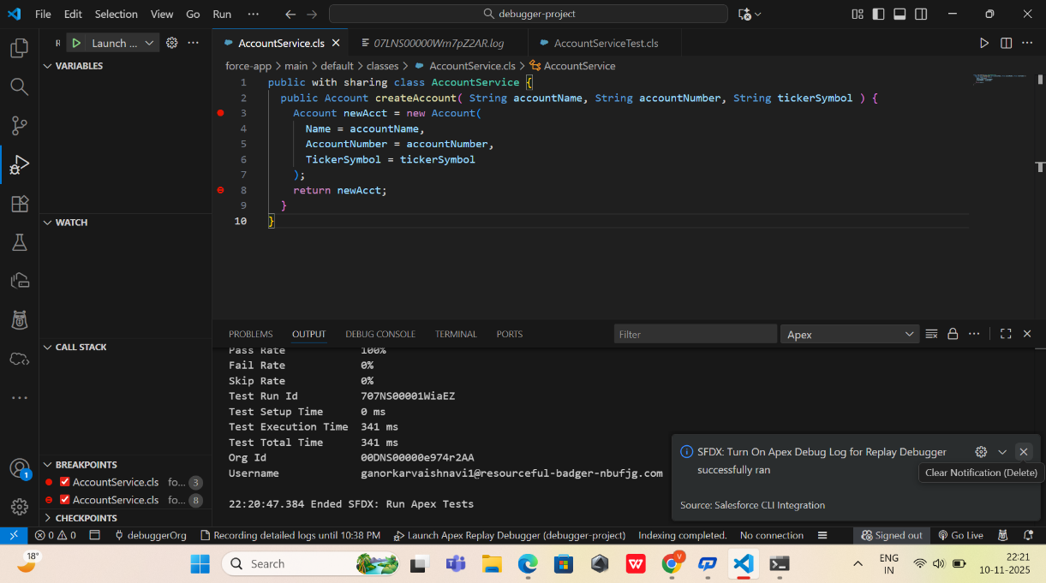
- 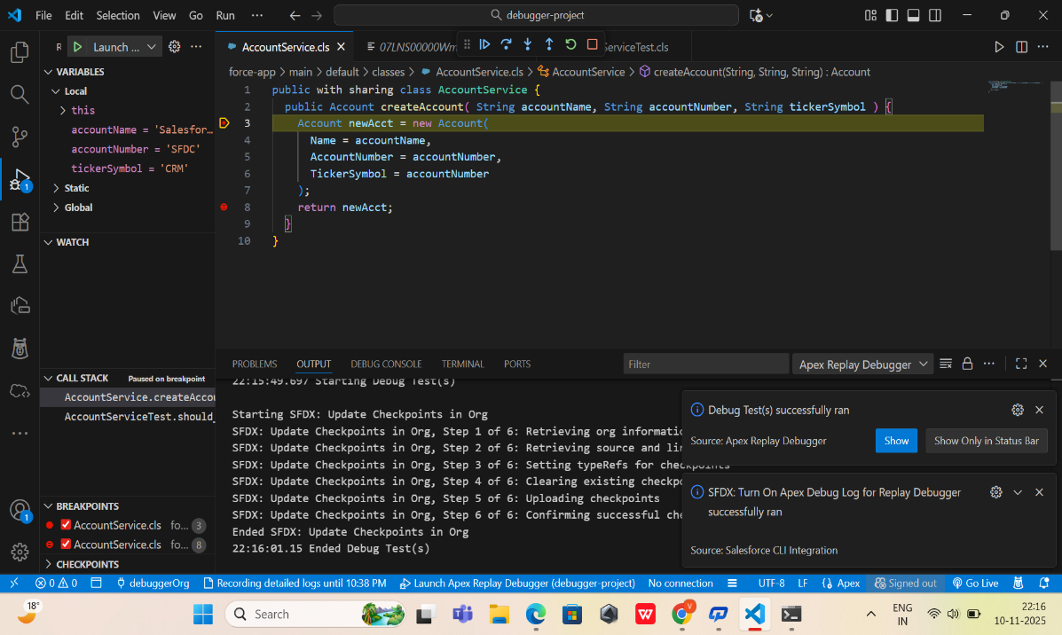

5. Deliverables of Phase 8
By the end of this phase:
✔ Test data for debugging is ready and consistent
✔ Apex classes and test classes are deployed successfully
✔ UI components (if any) are deployed and connected
✔ Logs generated during test execution are ready for Replay Debugger
✔ Project is fully set up for end-to-end debugging workflow

6. Outcome
- All Salesforce DX metadata and test data are properly deployed and ready to execute.
- Debugging workflow is fully functional with real or test data.
- Apex Replay Debugger can now replay debug logs and help identify or fix bugs accurately.

